**Proposed by:**

**Anupoma Debnath                           Monjila Moni**

Roll: 1807108                             Roll:1807112

**Under The Guidance Of:**

**Mohammad Insanur Rahman Shuvo**         **Md. Motaleb Hossen Manik**

Lecturer                                                         Assistant Professor

Department of Computer Science and          Department of Computer Engineering                     Science and Engineering

**Khulna University of Engineering &          Khulna University of &Technology                               Engineering & Technology**

**"Smart Stick for Blind people"**

**Course No: CSE 3104**

**Course Title: Peripherals and Interfacing Laboratory**

**Date:24 May,2022**

**Project Name:**  A smart stick for blind people

**Objectives:**

In this Project, we will make a Smart Stick for Blind People. Our goal is to build it in such a way so that a visually impaired person can walk without anyone's help. The stick will automatically detect the obstacle in front of the person and give him a response with a warning sound and/or vibrating the stick. We will use an Ultrasonic sensor for detecting the obstacles. Our objective is to add solutions to as many situations as possible

**Introduction:**

Visually impaired people depend on their surroundings mostly for mobility. The number of people who could be independent but bounded by this drawback is alarming.

2021 has seen the official launch of the International Agency for the Prevention of Blindness’s Vision Atlas – a compilation of the very latest eye health data. The report reveals that globally there are 43 million people living with blindness and 295 million people living with moderate severe visual impairment. Out of these, a huge 77% is completely preventable or treatable. This means that *33 million* people are living with *avoidable blindness* and a further *260 million* with *avoidable visual impairment* that is moderate-to-severe. Most people who are visually impaired don’t use a white cane. In fact, only an estimated 2 percent to 8 percent do. The rest rely on their usable vision, a guide dog or a sighted guide.

Our target is to make white cane popular among these people in a way that the cane can actually help them in independent movement. A stick that is actually helpful in the streets.

Our smart walking stick is specially designed to detect obstacles which may help the blind and severely visually impaired people to navigate care-free. After detecting obstacle buzzer beep for several times as predefined. This stick can also detect water as well as hole. So that a blind people can walk safely. There we also designed a function that can sense night and the led will automatically flame up after detecting darkness. In this way, when a blind people will walk at night, the people who are not blind can understand easily that there might be someone or a blind people walking.

**Apparatus Required:**

* An Arduino Uno Board
* A Laptop
* A 9 volts battery
* 2 Ultrasonic Sensor
* A 9 volts battery connector
* BC547 transistor
* 100k-ohm resistor
* 2 LED
* 3 Buzzer
* Jumper wire
* 1 Breadboard
* Male to female wire
* Male to male wire
* 1 Water sensor
* 2 LDR
* 1 Power Bank

**Other tools and equipment:**

3/4inch diameter stick, insulation tape, some small screws for mounting Arduino board, screwdriver, utility knife, instant adhesive glue, cardboard, scotch tape

**Project Description:**

**General Features:**

The stick starts after power on. And buzzes once as the signal of starting. Then the sonar starts scanning for obstacles and holes which can be of risk for the user. If the obstacle is in 2 meters range but further than that the stick notifies its user by buzzing once. If the obstacle is in less than 0.5 meter then the buzzer buzzes continuously to notify the user. If there is a hole which has depth of more than 1 ft then the buzzer buzzes continuously. In this case the user will get a bit of trouble while using a stair. We intend to solve the problem while building this project. We also want to notify the user in case of any water bodies close to feet by using this stick which is to be added after the primary building proposed in this paper.

**Methods to make this project:**

We follow the following flowchart to accomplish our project:

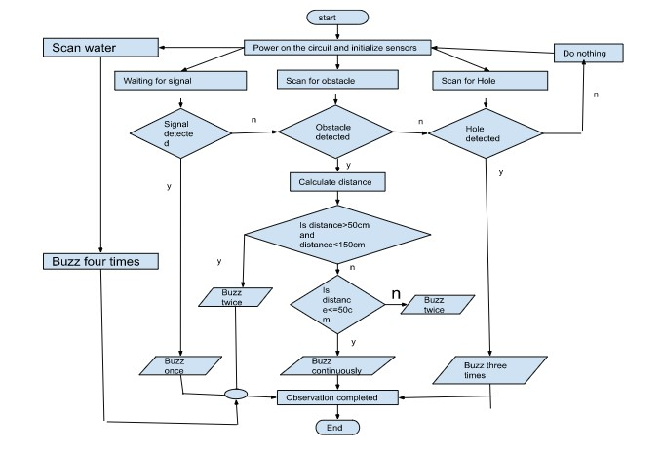

**Fig:** Flowchart for smart blind stick project

Firstly, we took a stick to set our project. Then we took a SONAR and some male to female wire and some male to male wire and buzzer. Then we put the below code to Arduino Software:

-------------------------------------------

const int buzzer1 = 3;

const int trigPin1 = 5;

const int echoPin1 = 6;

long duration1;

int distance1;

int safetyDistance1;

void setup() {

pinMode(trigPin1, OUTPUT); // Sets the trigPin as an Output

pinMode(echoPin1, INPUT); // Sets the echoPin as an Input

pinMode(buzzer1, OUTPUT);

pinMode(waterSens, INPUT);

pinMode(buzzer3,OUTPUT);

Serial.begin(9600);

}

void loop() {

digitalWrite(trigPin1, LOW);

delayMicroseconds(2);

// Sets the trigPin on HIGH state for 10 micro seconds

digitalWrite(trigPin1, HIGH);

delayMicroseconds(10);

digitalWrite(trigPin1, LOW);

// Reads the echoPin, returns the sound wave travel time in microseconds

duration1 = pulseIn(echoPin1, HIGH);

// Calculating the distance

distance1= duration1*0.034/2;

safetyDistance1 = distance1;

if(safetyDistance1<=50){

tone(buzzer1, 4050);

delay(200);}

else if (safetyDistance1>55 && safetyDistance1<70){

tone(buzzer1,4050);

delay(200);

noTone(buzzer1);

delay(200);

tone(buzzer1,4050);

delay(200);

noTone(buzzer1);

delay(800);

}

//no occurance

else{

noTone(buzzer1);

}

---------------------------------------------------------

After passing this code to our connected circuit we check that is working perfectly.

Then we move to our next SONAR circuit to detect hole. Bellow codes for hole detection:

---------------------------------------------

const int trigPin2 = 7;

const int echoPin2 = 9;

const int buzzer2 =2;

long duration2;

int distance2;

int holeDetection;

void setup(){

pinMode(trigPin2, OUTPUT); // Sets the trigPin as an Output

pinMode(echoPin2, INPUT); // Sets the echoPin as an Input

pinMode(buzzer2, OUTPUT);

Serial.begin(9600);

}

Void loop(){

digitalWrite(trigPin2, LOW);

delay(200);

digitalWrite(trigPin2, HIGH);

delay(10);

digitalWrite(trigPin2, LOW);

duration2 = pulseIn(echoPin2, HIGH);

distance2= duration2*0.034/2;

holeDetection = distance2;

if (holeDetection>30 && holeDetection<1200){

tone(buzzer2,3050);

delay(200);

noTone(buzzer2);

delay(200);

tone(buzzer2,3050);

delay(200);

noTone(buzzer2);

delay(200);

tone(buzzer2,3050);

delay(200);

noTone(buzzer2);

delay(800);

Serial.print("hole distance : ");

Serial.println(holeDetection);

}

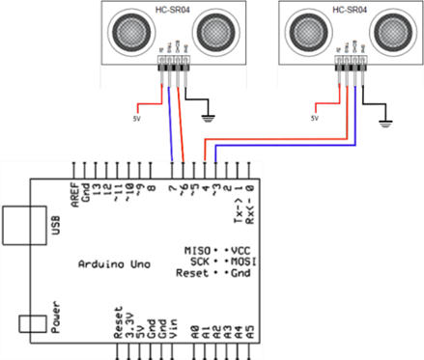

Fig: Ultrasonic Sensors and Arduino Circuit Reference diagram

After this we set circuit for water sensor and put the below code:

const int waterSens = A0;

const int buzzer3 =8;

int waterVal;

void setup() {

pinMode(waterSens, INPUT);

pinMode(buzzer3,OUTPUT);

Serial.begin(9600);

}

void loop() {

waterVal = analogRead(waterSens);//read the water sensor

if(waterVal>500){

tone(buzzer3,1650);

delay(200);

noTone(buzzer3);

delay(200);

tone(buzzer3,1650);

delay(200);

noTone(buzzer3);

delay(200);

tone(buzzer3,1650);

delay(200);

noTone(buzzer3);

delay(200);

tone(buzzer3,1650);

delay(200);

noTone(buzzer3);

delay(300);

Serial.print("Water Level: ");

Serial.println(waterVal);

}

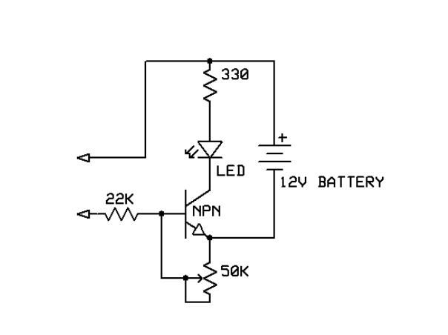

**Fig:** Water Sensor circuit reference diagram

--------------------------------------------------------------

Once we are sure that our circuit is working perfectly, then combine the hole code and test again.

After successful implementation, set all the instrument on the stick. And finally, we set darkness sensor circuit and set hole components to the right place.

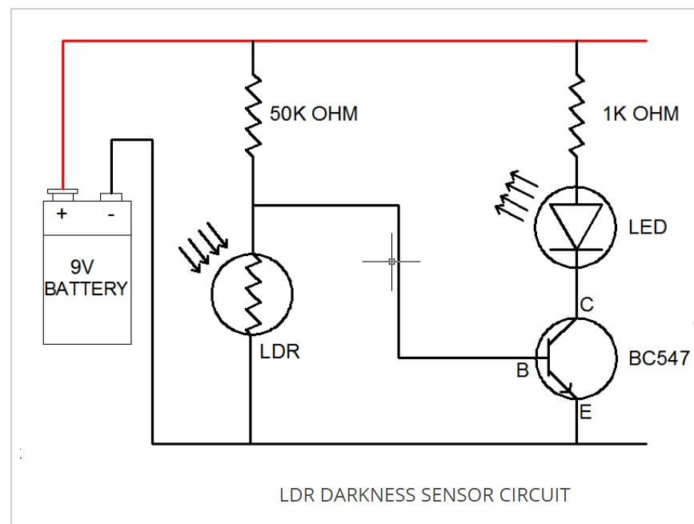

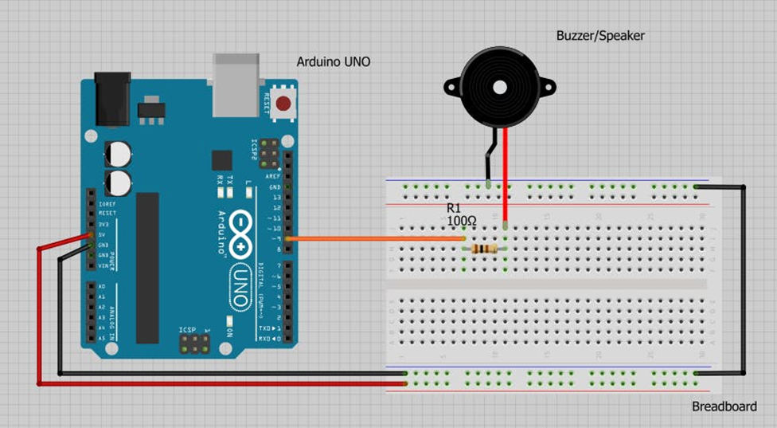

Fig: Buzzer (Piezo Buzzer) Module using Arduino Uno Reference diagram

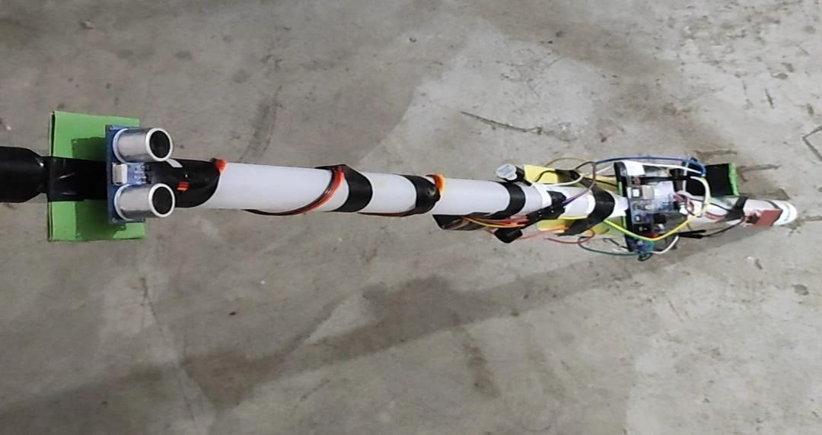

Fig: Complete project picture

**Conclusion:**

A visually impaired person can gain freedom of movement with the help of this stick other than using a help dog or a guide. This stick detects different kinds of obstacles in front of the person and gives a response to the user by buzzing. So, the person can walk without any fear. As this stick can detect water and hole as well, a blind people can walk like a normal people. The darkness sensor set at the stick can also help a blind people to walk at night. The LED will led when it found darkness, at the time normal people can easily understand that their may be someone. This design is also very cost-efficient and practical (light weighted). It has low repair cost and can be used over a long time without any trouble, also can be carried anywhere. We believe, self-dependence of every person is their birthright and with a little technological help, it can be gained.